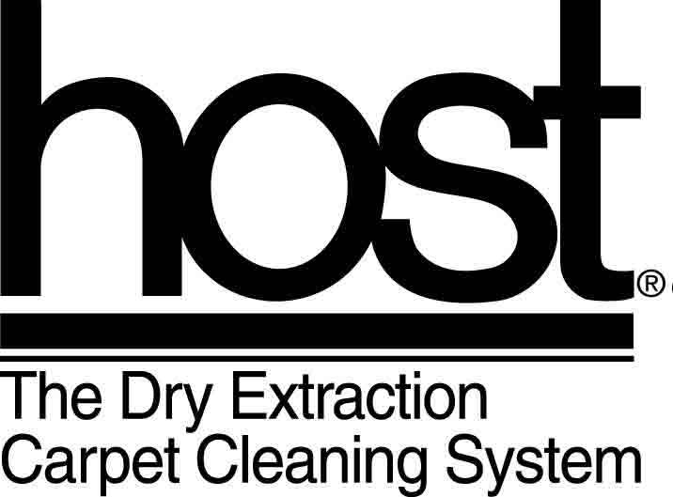
COSHH Information
Host Odour Neutraliser

1. PRODUCT AND COMPANY IDENTIFICATION
Product name: HOST® SMOKE-X® Odour Eliminator
Product category: general purpose, non-aerosol deodorant
Product usage: spray on a fine mist to deodorise interior furnishings and surfaces (refuse containers, kennels) nursing homes, hotels, residential and commercial premises.

Manufacturer: Racine Industries, Inc.
1405 16th Street
Racine, WI 53403 USA
Tel: 00 1-262-637-4491

Emergency contact after hours: G. J. Botting – 00 1-262-681-7431

UK Head Office: Host
Unit 6b Capenhurst Technology Park
Capenhurst Lane
Capenhurst
Cheshire
CH1 6EH
Tel: 0151 347 1900
Fax: 0151 347 1901
Email host@hostvs.co.uk
www.hostvonschrader.co.uk

2. COMPOSITION / INGREDIENTS
Hazardous ingredient:
Ethyl Alcohol Cas #64-17-5 1.38% TLV = 1,000 ppm
Note: dilute product 1:16 for use. Use dilution contains 0.86% alcohol.

3. HAZARDS IDENTIFICATION
This product is not classified as hazardous to health or the environment.

4. FIRST-AID MEASURES
In case of overexposure or extreme sensitivity:
Skin contact: rinse with water
Inhalation: remove to fresh air
Eye contact: rinse with water
Ingestion: rinse mouth with water; do not induce vomiting; seek medical advice if large amount has been swallowed

5. FIRE-FIGHTING MEASURES
The product is not flammable

6. ACCIDENTAL RELEASE MEASURES.
Mop or soak up with absorbent material such as cotton or paper toweling. No special precautions necessary. Rinse area with water and mop dry.

7. HANDLING AND STORAGE
Does not require any special handling. Recommended temperature for storage is 32 to 100°F
(0-38°C)

8. PERSONAL PROTECTION / EXPOSURE CONTROLS

No protective equipment is necessary.
Gloves advised for sensitive skin; ventilation advised for asthmatics.
No known harmful effect from repeated, long-term exposure.

9. PHYSICAL AND CHEMICAL PROPERTIES

Physical state: liquid
Colour: concentrate - amber, cloudy; use dilution (1:16) - colourless, cloudy
Odour: pine
pH: concentrate - 8.5; use dilution (1:16) - 7.5
Specific gravity: 1.01
Vapour pressure: (mm Hg): 18.41 @ 70°F (21°C)
Boiling point: >197°F (>98°C)
Flash point: > 212°F (>100°C) by Setaflash cc

10. STABILITY AND REACTIVITY
Stable

11. TOXICOLOGICAL INFORMATION

No toxic effects TEST PERFORMED RESULT
Not a skin irritant OECD 404 Primary Skin Irritation Negative
No oral toxicity OECD 401 - Oral Toxicity LD₅₀ > 5 gm/kg
No inhalation toxicity OECD 403 - Inhalation Toxicity LC₅₀ > 5.0 mg/l
Not an eye irritant OECD 405 - Eye Irritation Negative: use dilution
Slight: concentrate

12. ECOLOGICAL INFORMATION
Biodegradable

13. DISPOSAL CONSIDERATIONS

No special precautions According to local regulations - can be landfilled

14. TRANSPORT INFORMATION
No special labeling required.

15. REGULATORY INFORMATION
None. Not a regulated product.
DOT (Canada & U.S.): no special labeling.
Canadian WHMIS: not a controlled substance. No special labeling.
Canadian Consumer Regulations: not a restricted substance. No special labeling.
California Prop. 65: no listed ingredients. No special labeling.
New Jersey Right-to-Know: identical to consumer goods. No special labeling.
EEC Regulations: no special labeling. Not a dangerous preparation.

16. OTHER INFORMATION

HMIS (Hazardous Materials Information System) rating: Health = 0;
Flammability = 0; Reactivity = 0; Personal Protection = none required.

Scale: 0 = minimal; 1 = slight; 2 = moderate; 3 = high; 4 = extreme

